**GIT**

Git is basically a Version Controlling system used to track changes in the files. It becomes more effective and important while multiple developers working on the same modules or files.

**Setup GIT Repo**

This document demonstrates (step by step) about how to setup Git Repository initially and how to work with GIT Repositories that are already setup.

**1. Install Git Bash:**

Install Git/Git bash to use GIT on your machine by using this URL <https://git-scm.com/download/win>.

**2. Setup Repo:**

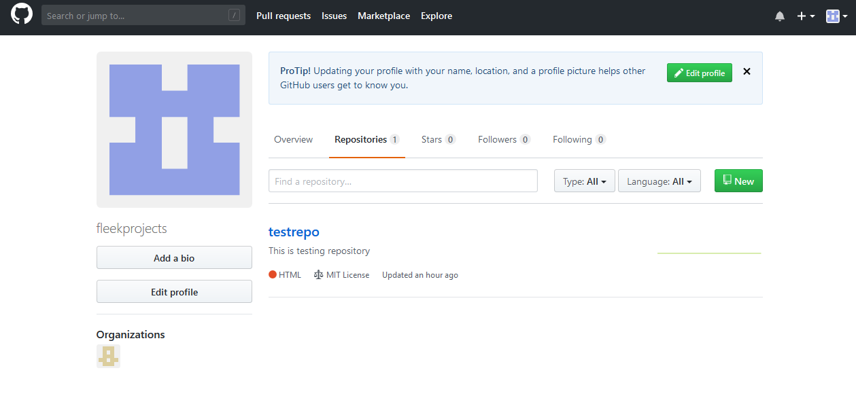Now login to origin i.e. GitHub or BitBucket and create an empty repository by clicking the new button.

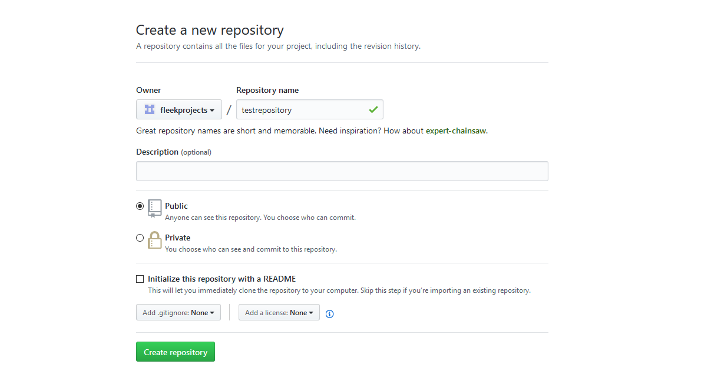

Enter your repository name and don’t check on the Readme File option as we are going to make this repository with existing project at our local machine.

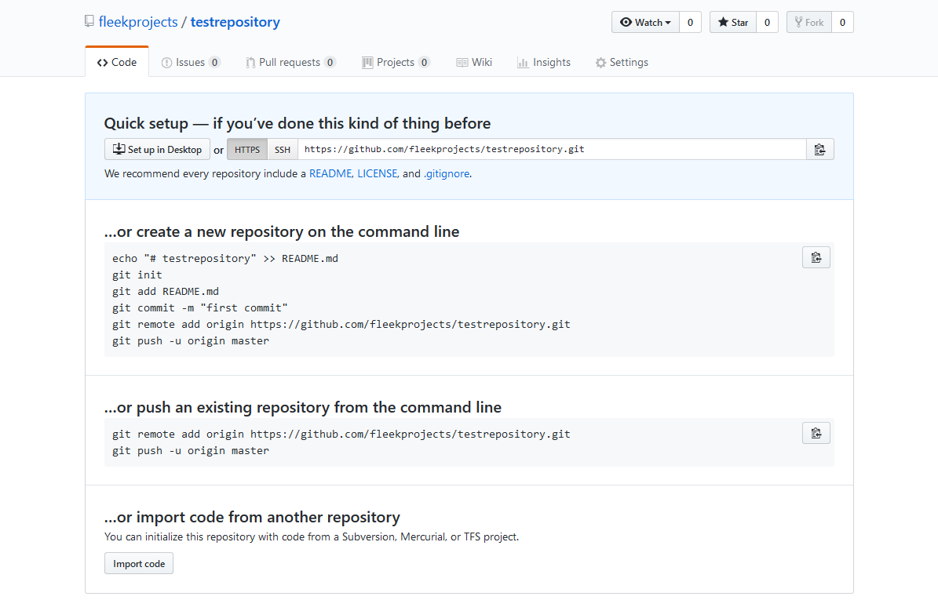

The repository URL is Https URL i.e. <https://github.com/fleekprojects/testrepository.git> in this case

**3. Git Bash:**

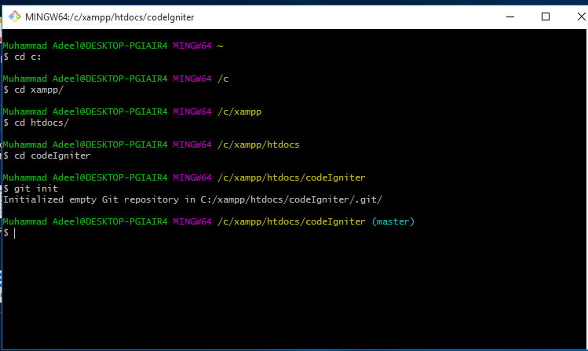

Now open GIT bash on your local machine and move to your project directory. Use the command “git init” to initiate GIT repo at your local.

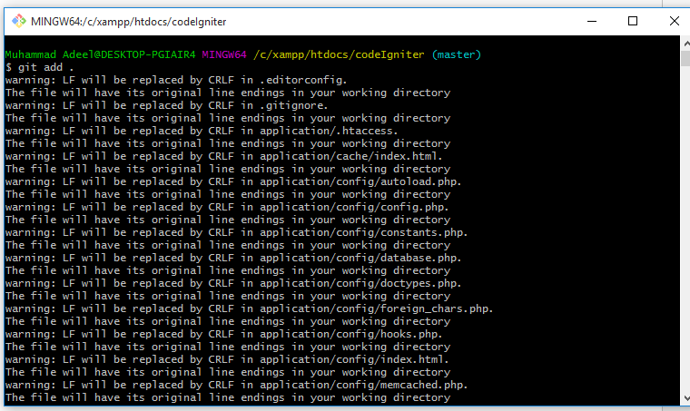

Use command “git add .” to add all the files for commit. Git add command get the files/changes ready for commit.

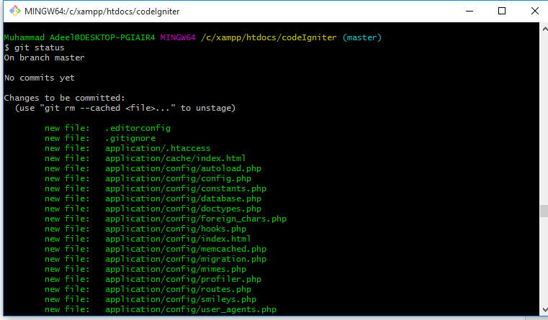

Use “git status” command to check the status of files added/ready for commit.

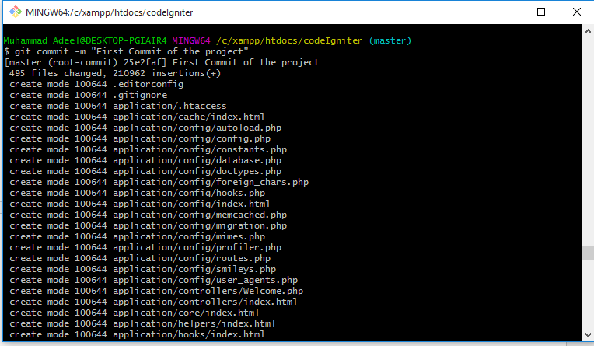

Use git commit –m “commit message” command to make commit. After making the commit the working directory should be clean.

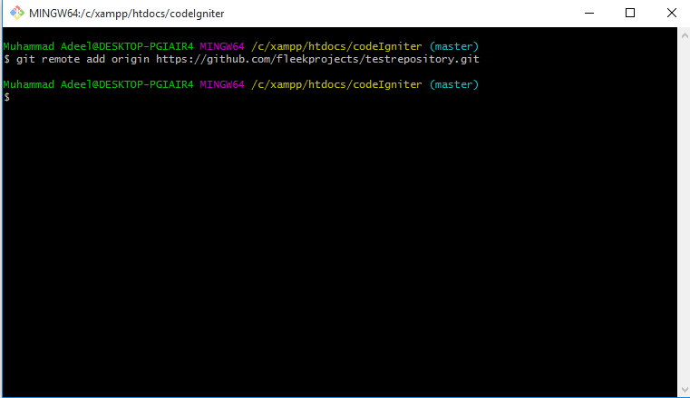

Now you need to add the origin i.e. repository URL to push the changes to Origin (i.e. GitHub / Bitbucket). Use this command to add origin “git remote add origin repository_url”

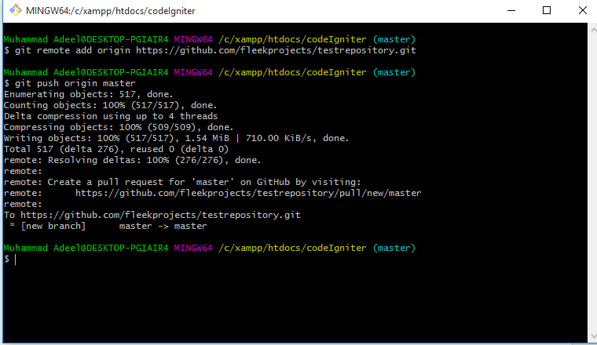

Use command “git push origin master” to push the changes to the repository (origin)

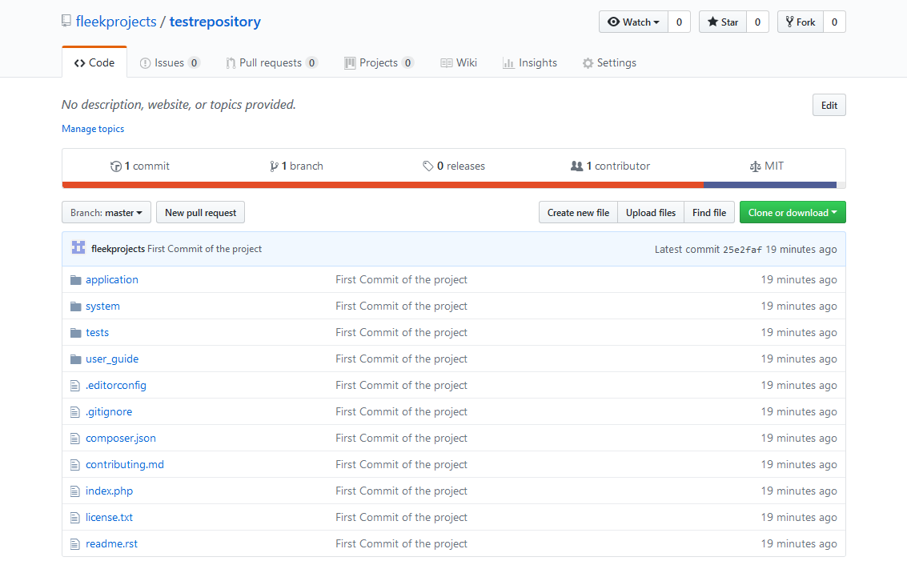

After successful PUSH your repository should look like this. All the files of the projects should be there at Origin (GitHub / BitBucket)

**For existing repo’s**

To work on existing repositories you need to clone that repository to your working environment. Go to your working directory and use command “git clone repository_url” i.e. “git clone <https://github.com/fleekprojects/testrepository.git>”

**For Fresh Installation**

In case if any developer has the fresh installation of GIT/GIT bash there should be an error/message occur like config global username or email.

For those error/message use the following command to enter your details.

git config --global user.email “your origin email”

git config --global user.name “your origin username”

**GIT Ignore**

GIT ignore is a file with convention like ‘.gitignore’. It is used to secure some files to not to track with GIT. What you need to do is to enter the files/rules to “.gitignore” file.

**Useful Links:**

<https://git-scm.com/download/win>

<https://help.github.com/articles/adding-an-existing-project-to-github-using-the-command-line/>

<https://github.com/joshnh/Git-Commands>